RIVER VALLEY HIGH SCHOOL
General Certificate of Education Advanced Level
Preliminary Examination 2024
Higher 2
H

GEOGRAPHY 9173/01
Paper 1 9 September 2024
INSERT 3 hours

READ THESE INSTRUCTIONS FIRST

This Insert contains all the Resources referred to in the questions.

___________________________________________________________________
This document consists of 8 printed pages.

[Turn over

Resource 1 for Question 1

The location and amount of economically viable oil reserves at different oil prices in 2016

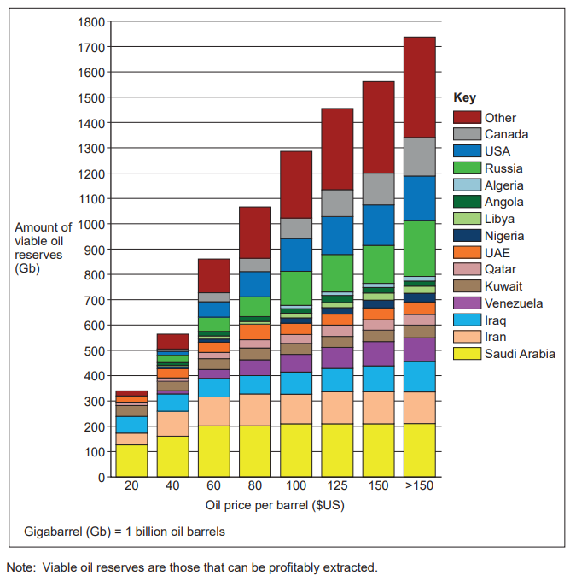

Resource 2 for Question 1

Information produced by the Canadian government about tar sand developments in Canada
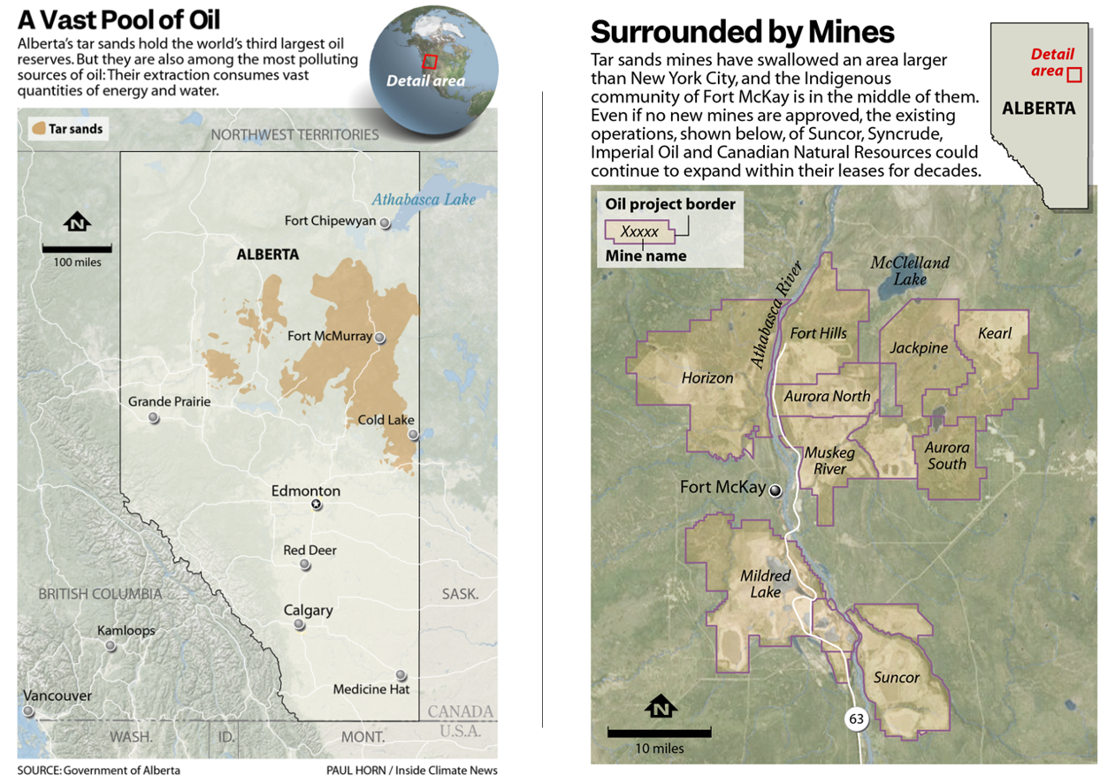

Resource 3 for Question 1

A tar sand oil production area in Alberta, Canada

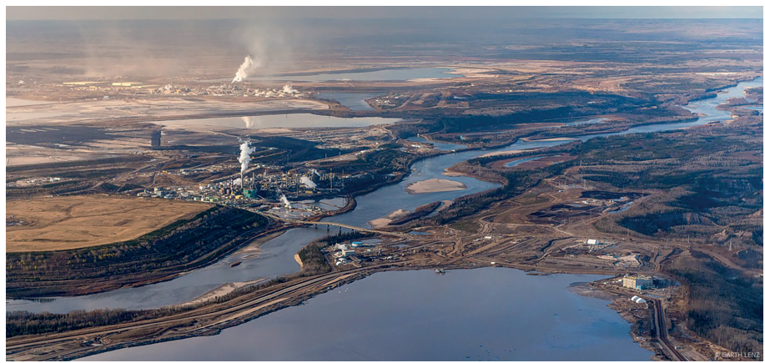

Resource 4 for Question 1

Minerals and the associated geology found in part of northwest England
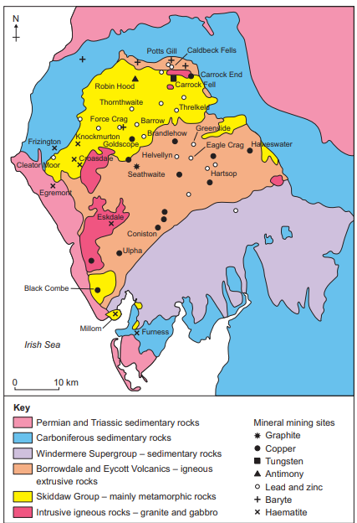

Resource 5 for Question 2

Temporal distribution of reported mass movement events in Western Cape, South Africa
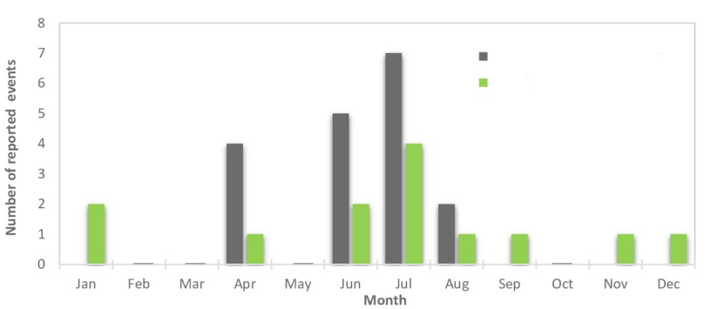
Flows
Falls

Resource 6 for Question 2
Resource 6A:
Percentage of land that is very highly susceptible to landslides in the districts of Kerala, India

Resource 6B:
Districts of Kerala, India

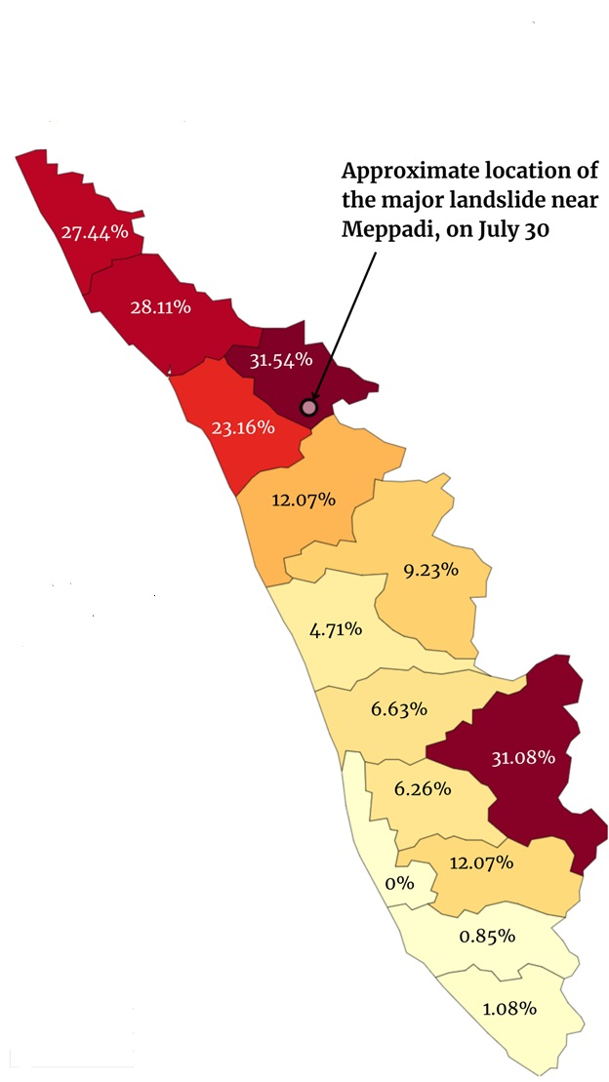
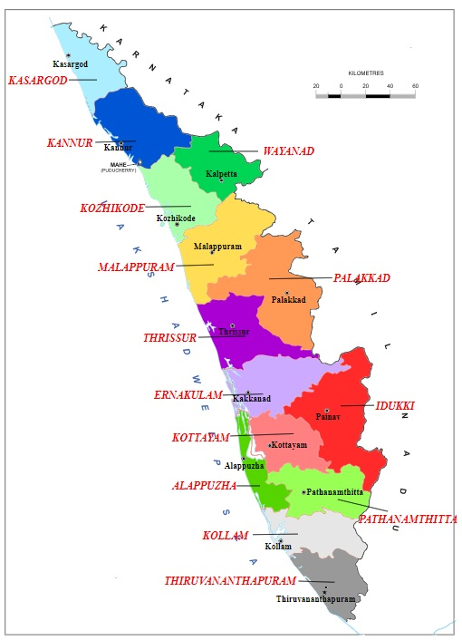

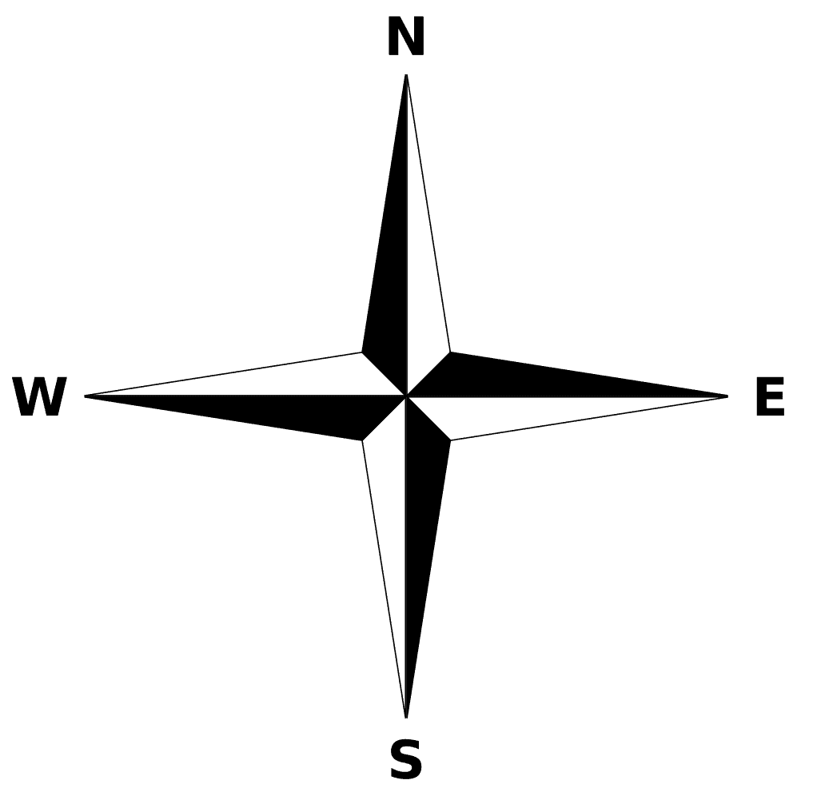

Resource 7 for Question 2

An abstract from a news article on the causes of the 30 July 2024 landslide near Meppadi in Wayanad district, Kerala

The proximate cause of the disaster was unrelenting monsoon rain. The Indian Meteorological Department said Wayanad had received 28cm of rain in the 24 hours before the landslides struck and destroyed critical infrastructure like roads, bridges and power lines along with homes and crops.
Kerala is no stranger to intense monsoon rainfall given its geography, flanked by the Arabian Sea to the west and the Western Ghats mountain range to the east. But this monsoon has been particularly severe, leading to swollen rivers, landslides and extensive flooding in the southern state as also elsewhere in the country.
Human activities also played a crucial role in contributing to the disaster. Deforestation, unplanned urban development and poor land-use practices have significantly compromised the region's natural defences.
As India has sought to develop economically over the past few decades, it has built roads, bridges and mines in hilly regions. From the Himalayas in the north to the Western Ghats in the south, however, these mountainous areas are fragile.
More than half of the Western Ghats mountain range is at risk of landslides, a government panel found and called for it to be declared ecologically sensitive with the most sensitive regions protected from any kind of human activity.
According to a 2021 study, 56 per cent of Kerala’s landslides occurred in plantation areas. The plantations often stand where lush forests once thrived. Wayanad lost 62 per cent of its forest cover between 1950 and 2018, according to a study published in the International Journal of Environmental Research and Public Health.

Resource 8 for Question 2

Land use map of the Mekong Delta in 2015
